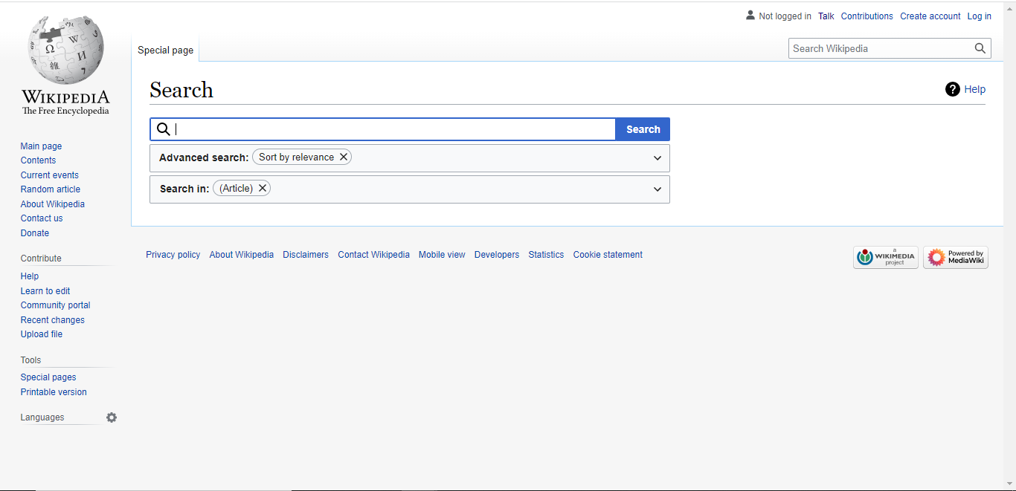

1. On left side we have page links.
2. We have search functionality.
3. When we click on advance search functionality form will open.
4. When click on search in there is checked boxes when you click on it according to checkbox it open popups.
5. In bottom we have multiple page links
6. Not logged in means you not loge in wiki.
7. Talk means you can talk with contributors.
8. Contribution means it will track you IP address.
9. Create your account and login it’s a general process.
10. There is logo in right bottom when you click on it, it will redirect to sponsor page.